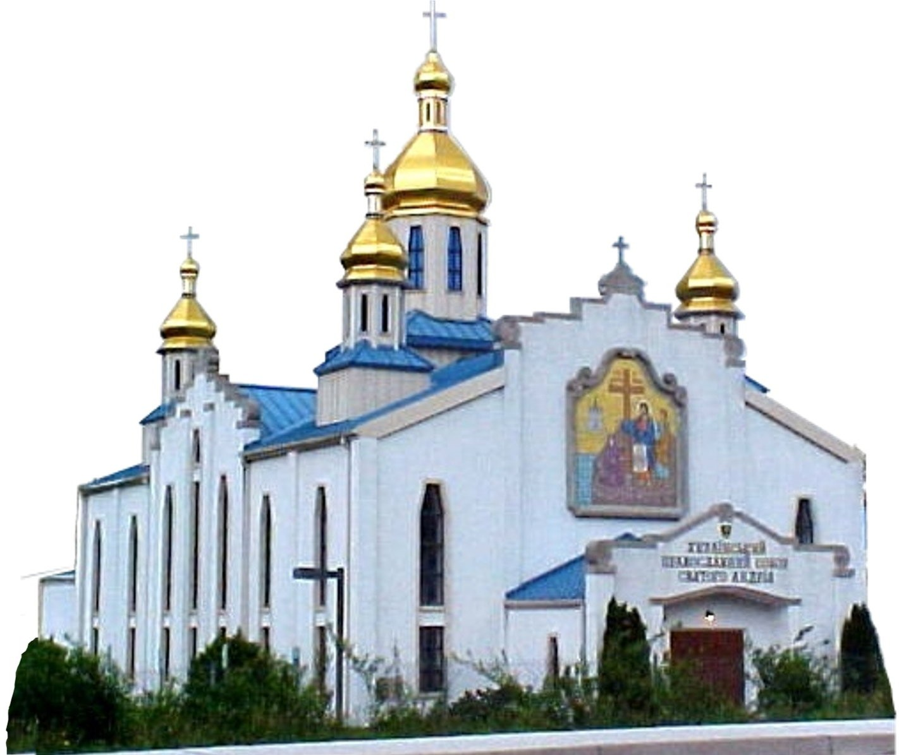
St. Andrew’s
Ukrainian Orthodox Cathedral
Metropolitan Washington D.C.

Who could have imagined that as we move into 2024 Ukraine would find itself still subjected to barbaric acts from russia. Innocent civilians have been displaced and killed for reasons that no rational human can understand. Under this sad and black cloud, we express gratitude for the support that so many have given to help our parish spring into action in February 2022, and to create a Humanitarian Center. Providing substantive humanitarian aid to Ukraine and Ukrainians has become our major preoccupation. And we could never have succeeded without your incredible support – be it in financial donations or the giving of hours and hours of your precious time.
So many have been responsible for also keeping our parish strong in its day-to-day operations. Again, this year, on a glorious fall weekend, people came from far and wide to our parish grounds, to celebrate our beautiful culture at the 20th annual Washington Ukrainian Festival. Many in the parish contributed to making it another successful event. Witnessing how people volunteered their time to create this festival has been a wonder to behold. Thank you to all!
Our Parish Hall rentals resumed full steam, as COVID restrictions have been lifted, and we continue to make renovations to our parish hall. Typically, our hall rental has been our main income generator, supplemented somewhat by revenues from the Festival, but it is your generosity in pledges that is essential to fully cover parish operating expenses.
Therefore, as we begin the new year, we ask that you once again make an annual formal pledge to sustain our parish. Any amount is helpful and appreciated.
In the past, we have suggested a minimum pledge of $1200 a year per family. Some can do more, others less. We ask that you examine your own finances and consider making a generous pledge for 2024. Know also that, if you cannot fulfill your pledge, it is strictly between you and God, and no judgment is ever passed on you by us.
Knowing pledged amounts at the start of the year, is important to planning our annual budget. We therefore ask that you fill out a pledge form at your earliest convenience as this allows us to operate efficiently.
Please complete the 2024 pledge form and return it to the church office or scan / email it to admin@standrewuoc.org.
You can also mail it to: St Andrews UOC
P.O. Box 12076
Silver Spring, MD 20908
We thank you for your charitable contributions and support.

In Chirst,

Fr. Volodymyr Steliac Tamara Woroby
Parish Rector Parish Council

Український Православний Собор
Св. Ап. Андрія
Вашенґтон, США

His Eminence
Metropolitan Antony

***

Fr. Volodymyr Steliac
Pastor
Home: (301) 384-9192
Mobile: (301) 7171874
frvsteliac@gmail.com
15100 New Hampshire Ave.
Silver Spring, MD 20905

***

Dr. Tamara Woroby

Council President
President@standrewuoc.org
***

Olga Coffey
Treasurer
Office Administrator
admin@standrewuoc.org

St. Andrew
Ukrainian Orthodox Cathedral
Metropolitan Washington D.C.

Український Православний Собор
Св. Ап. Андрія
Вашенґтон, США

Pledging and Stewardship for 2024

Between January 1, 2024 and December 31, 2024, I/we pledge

to donate a minimum total sum of $___________________to

support our beautiful St. Andrew Ukrainian Orthodox Cathedral.

Name/s: __________________________________________

Signature: __________________________________________

Address: __________________________________________

__________________________________________

Phone: __________________________________________

Email: __________________________________________

His Eminence
Metropolitan Antony

***

Fr. Volodymyr Steliac
Pastor
Home: (301) 384-9192
frvsteliac@gmail.com
15100 New Hampshire Ave.
Silver Spring, MD 20905

***

- Today I included a partial payment check of my Pledge
  - Amount__________________

- Please accept a one-time donation to our church
  - Amount__________________

Dr. Tamara Woroby

Council President

(301) 622-5456

***

Olga Coffey
Treasurer
Office Administrator
(703) 606-9525
admin@standrewuoc.org

